

**BAHRIA UNIVERSITY (KARACHI CAMPUS**)

MIDTERM EXAMINATION –SPRINGSEMESTER – 2020

**(Probability & Statistics: GSC-122)**

Take Home Assignment

Class: **BS (CS)– 3A and 3B**  **(Morning)**

Course Instructor: **Ms. Dania Wahab and Engr**. **Ahmed Faraz** Submission Deadline: **31-May-2020**

Max Marks: 20

**Note:** All questions carry equal marks.

**Instructions**

* ‘Take Home Assessment Assignment’ for Midterm Spring-2020 is uploaded on Friday May 15, 2020 at 11am on LMS of CMS (BUKC).
* Student will return their hand written answer sheets as a combine PDF file till 6pm Sunday May 31, 2020. Early Submission will be highly appreciated.
* Students are required to comment for all necessary steps in solution.
* Students should develop proper title page for their PDF file consist of Name of Student, Registration / Enrolment number, Name of Assignment, Date of Submission, Class with section, semester, instructor name etc.
* Every page of PDF file must contain handwritten name, registration number and page number on the top left corner.
* Attempt all question by Blue or Black Pen only.
* Provide a related short summary as a result after every solution based on minimum 3 sentences.

**Q # 1a) College Football Scores**: On October 20, 2008, we obtained the following scores for week 8 of the college football season from the Sports Illustrated Web site, SI.com. Is this study descriptive or inferential? Explain your answer. (2.0)

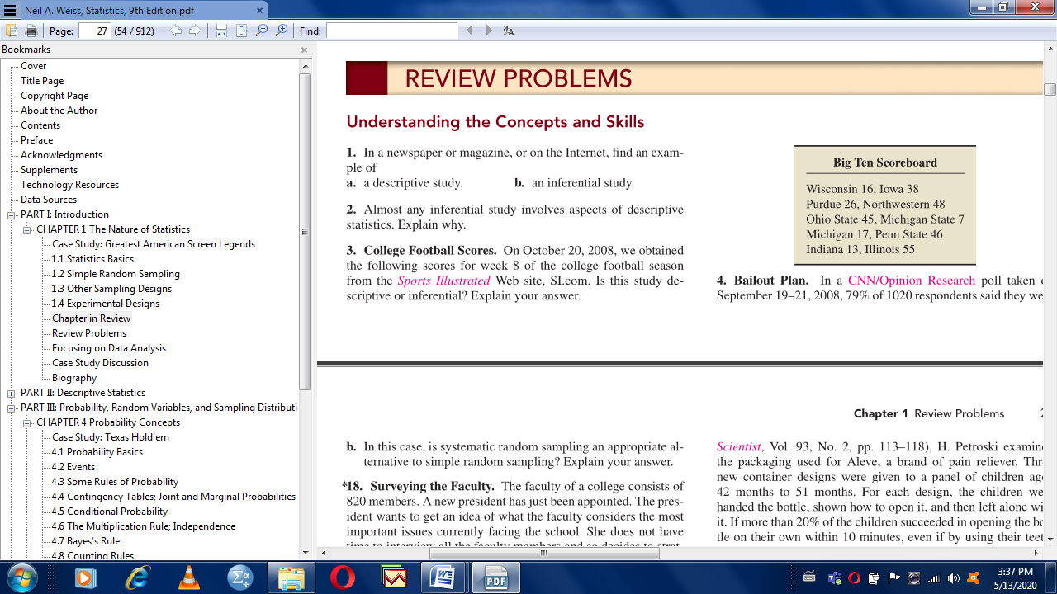

**Q # 1b) Surveying the Faculty**. The faculty of a college consists of 820 members. A new president has just been appointed. The president wants to get an idea of what the faculty considers the most important issues currently facing the school. She does not have time to interview all the faculty members and so decides to select the faculty by rank systematically and use systematic random sampling to obtain a sample of 40 faculty members. There are 205 full professors, 328 associate professors, 246 assistant professors, and 41 instructors. Start sequence the faculty member from Professor and end at number of instructors.

How many faculty members of each rank should be selected for interviewing? Use the following table to obtain the required sample. Explain your procedure in detail. (3.0)

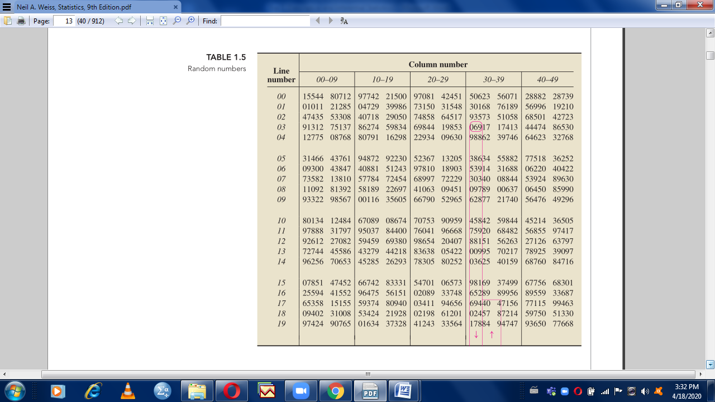

**Q # 2a)** Describe Binomial Expansion and calculate the coefficient of a2b5 in the expansion of (x + a + b + y)7? (1.5)

**Q # 2b)** A committee 5 members is to be selected from among 7 Labours and 10 Management persons. How many committees will have at-most 3 management representative? Also describe the combination concept. (2.0)

**Q # 2c)** Develop a tree diagram for two tosses of an unbiased dice. Provide all outcomes in a set form. (1.5)

**Q,,,,,,, # 3a)** In how many ways can the words “Marvellous” be rearranged? Also describe the concept of Permutation with all of its types. (2.0)

**`**

**Q # 3b)** Consider the following sample of MBA graduates, whose first salaries (in $1000 per annum) after graduating:

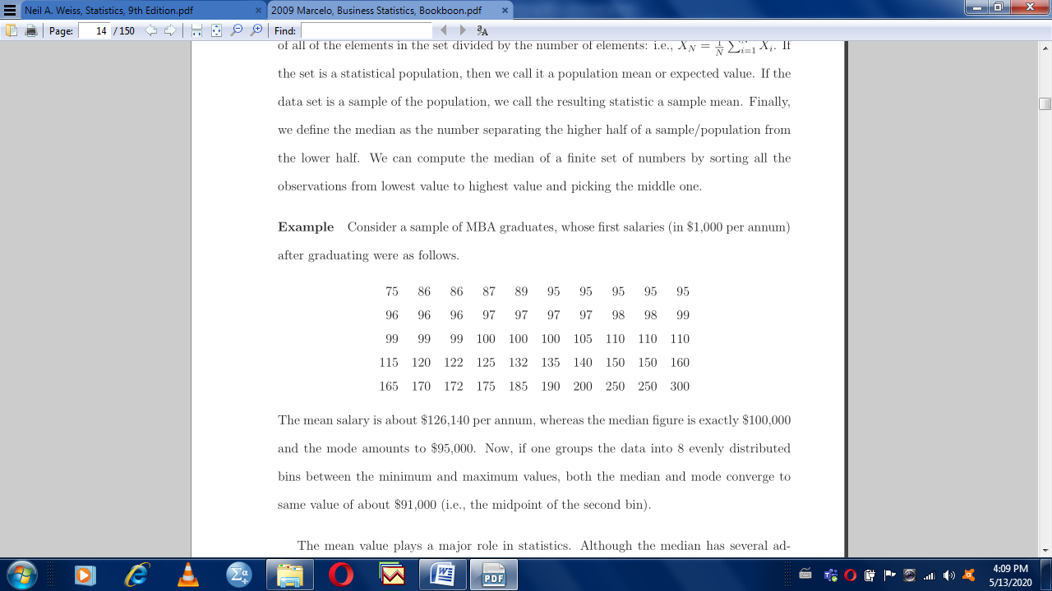

Construct a frequency distribution based on Class Interval, Class Boundaries, tallies, frequencies, midpoints, relative frequencies, cumulative frequencies, less than cumulative frequencies, and more than cumulative frequencies. (3.0)

**Q # 4)** Calculate the following statistical values with their conceptual description and show the result of part (1) to (6) on a frequency polygon: (Use the frequency distribution table created in **Q # 3b**) (5.0)

1. Mean,
2. Median,
3. Mode,
4. Quartiles, (Q1 and Q3),
5. Deciles, (D3 and D8),
6. Percentiles, (P6 and P73),
7. Inter-quartile range
8. 5-Point Box Plot
9. Variance,
10. Standard deviation